What are we learning?  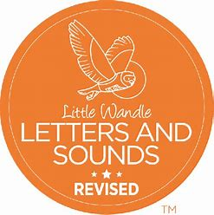  Focus phonemes for Nursery 2 this half term:  k e u r h b    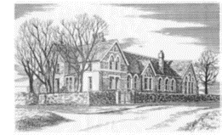 | Key Themes and books  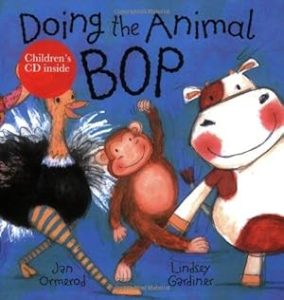  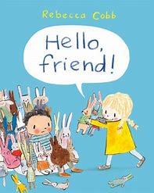  Let’s Explore 2  This will help us when we learn about:  Animal Life cycles (caterpillar, frog, plant), Animals around the world, Habitats-comparing places, Mini-Beasts Night and day animals and David Attenborough when we are in Rainbows  Key Learning  We will have a big focus on the signs of Spring this half term and learn how Spring brings new life of both animals and plants. We will talk about the animals we are familiar with such as our pets or farm animals and compare them with animals we might have never seen or heard of before! We will explore the animals and creatures we find in our local environment and begin to look at their life-cycles (Chicken) and what they need to help them survive and grow.  Key Themes  Spring, Down on the Farm, At the zoo, Mini Beasts, life-cycles, Easter  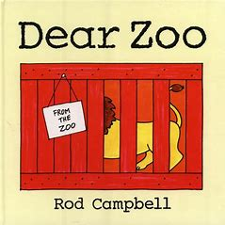  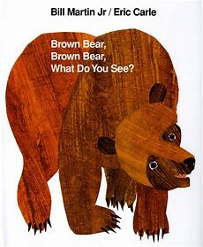  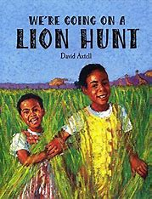 |  | Key Vocabulary  General Vocabulary  Animal  Pet  Farm  Zoo  Wild  Life-cycle  Insect  Spring  environment  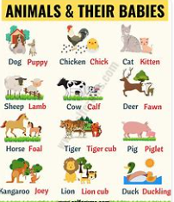  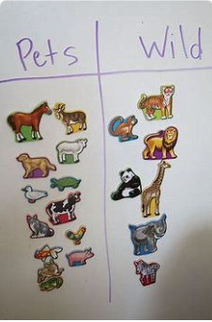  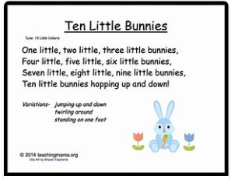  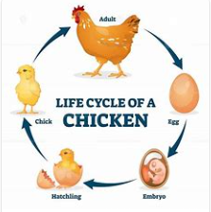
Ways to support at home  Read stories every day, talk about what you see in the pictures, can you spot any animals and name them?  Look for different animals when you are out and about, can you spot any of their young?  Look for signs of Spring, can you take a photo to share with us?  Can you sort you toy animals into different groups e.g. farm animals and Wild animals or 2 legs and 4 legs?  Play preposition games with you animals by hiding them for your chid to find focusing on vocabulary such as in, on, under, in-front and behind.  Practice subitising with your animals e.g. can your children recognise there are 3 cows without needing to count?  Make different shaped enclosures for animals using construction toys. |  | Nursery  Spring Term 2  2026   | We will encourage this learning by:  *Going on nature walks and mini-beast hunts around the school, using the iPad to take photos and making observational drawings  *Using natural materials and resources to make mini-beast habitats  *Looking at photos of Wild animals and comparing them to animals we are familiar with such as our pets or farm animals  *Sorting our animals into different categories  *Looking for information on animal life cycles in books and online with an adult  *Meeting some chicks and chickens  *Using their eggs to make yummy Easter treats  *Learning new songs, rhymes and poems linked to our topic  *Developing our climbing and balancing skills in the garden  *Using different ride-on vehicles  *Learning about Easter and that it is an important celebration for Christians
This half term in Sunbeams we will be developing the following skills:

The Prime areas
Communication and Language |  | Physical Development |  | Personal, Social and Emotional Development
Nursery 1  Start to develop conversation, often jumping from topic to topic. Confidently put 2/3 words together.  Identifies action words by following simple instructions e.g. who is jumping?  Nursery 2  Asking and answering questions  Developing sentence length  Participating in Little Wandle Rhyme Time, Love of reading and Foundations for Phonics sessions |  | Ongoing throughout nursery…  Gross Motor Skills:  Climbing on various equipment; Crawl, walk, run, jump, matching skill to task; Use large muscle movements to wave flags and streamers; Kick, throw and catch a ball; Clap and stamp to music; Dance and hold a pose; Paint and make marks; To be able to begin to sit on a push-along wheeled toy (2-3 years); Riding tricycles (3-4 years); Going up and down stairs; Carrying heavy items; Washing windows and toys; Building with large construction  Fine Motor Skills:  Use tools and equipment like spades, spoon and fork, water jugs, scissor scoops, tweezers, large pipettes; Funky finger activities; Play-dough (dough disco); Tearing Paper; Scissors- sniping paper progressing to moving forwards; Mark making using a variety of tools and media; Use of Clips, Clasps, zips, buttons, screwing Jars and nuts and bolts; Finger Puppets |  | Nursery 1  Begin to show ‘effortful control’. For example, waiting for a turn and resisting the strong impulse to grab what they want or push their way to the front  Begin to use ‘you, me and I’ in talk  Nursery 2  Develop ways of being assertive  Develop independence in managing own care needs
The Specific Areas
Mathematics | Literacy |  | Understanding of the World |  | Expressive Arts and Design
Nursery 1  Developing understanding of language  Compare saying bigger, smaller, high, low, tall, heavy  Developing understanding of positional language  Recites numbers in sequence 1-5  Nursery 2  Maths: Patterns and number  Number recognition.  Link numbers to amounts  Counting amounts to go with numbers.  Ordering | Nursery 1  Ask questions about the book. Makes comments and shares their own ideas  Join in with songs and rhymes, copying sounds, such as loud, quiet, fast, slow, using instruments  Sing songs and say rhymes independently, for example, singing whilst playing.  Add some marks to their drawings, which they give meaning to. For example: “That says mummy.”  Nursery 2  Talks about the different parts of a book  Discriminates between different sounds (animal)  Recognises rhyming words in games, stories and poems.  Recognises familiar logos and labels in the environment  To know that text has meaning.  Builds an understanding that text is read from right to left  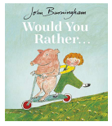  Core Little Wandle text |  | Nursery 1  Can talk about their immediate family, relations and pets  Talks about some of the things they’ve observed such as plants, animals, natural and found objects  Explore collections of materials with similar and/or different properties.  Mechanical toys, e.g., turns the knob on a wind-up toy or pulls back on a friction car.  Nursery 2  Begin to understand the need to respect and care for the natural environment and all living things  Use all their senses in hands on exploration  Know that there are different animals and that they live in different parts of the world  Toys with knobs or pulleys, or real objects such as cameras or mobile phones.  To be able to begin to acquire basic skills in turning on and operating some ICT equipment |  | Nursery 1  Make simple models which express their ideas.  Makes marks intentionally. (in flour, sand, pens, crayons, paint etc.)  Join in with songs and rhymes, making some sounds.  Nursery 2  Develop stories using small world equipment like animal sets, dolls and dolls houses etc  Develop pretend play with others  Use available resources as props  Plays instruments with increasing control to express feelings and ideas  Move in a range of ways

